Terraform Task-2
Task Description:
Create 2 EC2 instances on 2 different regions and install nginx using terraform script.

Terraform installed on local machine:
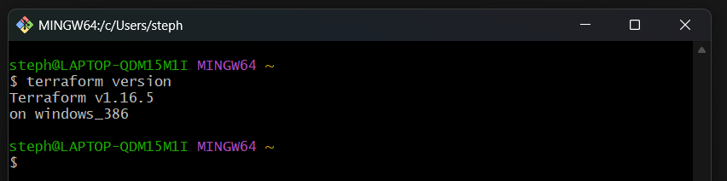

AWS CLI installed and aws authentication has been enabled:
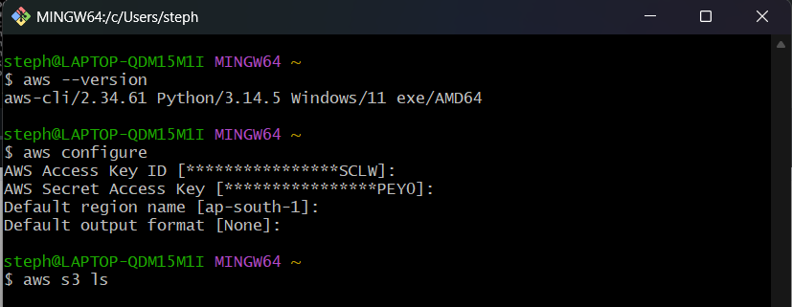
Initializing terraform:
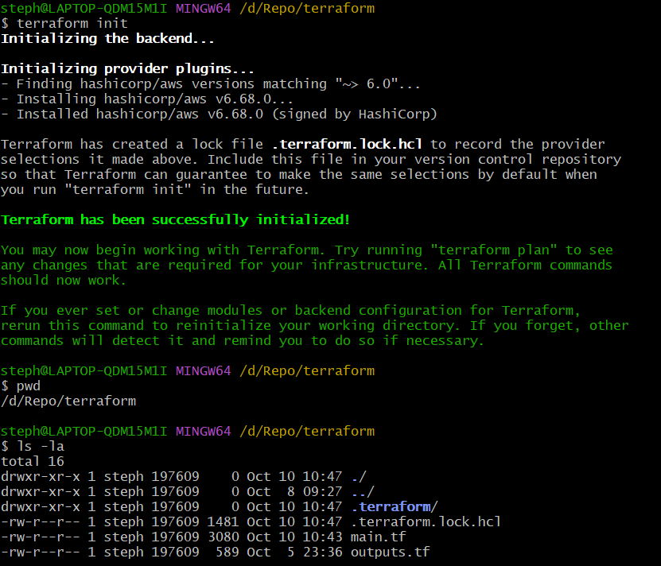
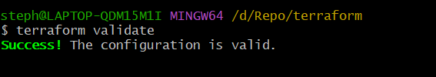
Below main.tf terraform script - is used to Create 2 EC2 instances on 2 different regions and install nginx also.
- Creating aws provider and security group for both regions.
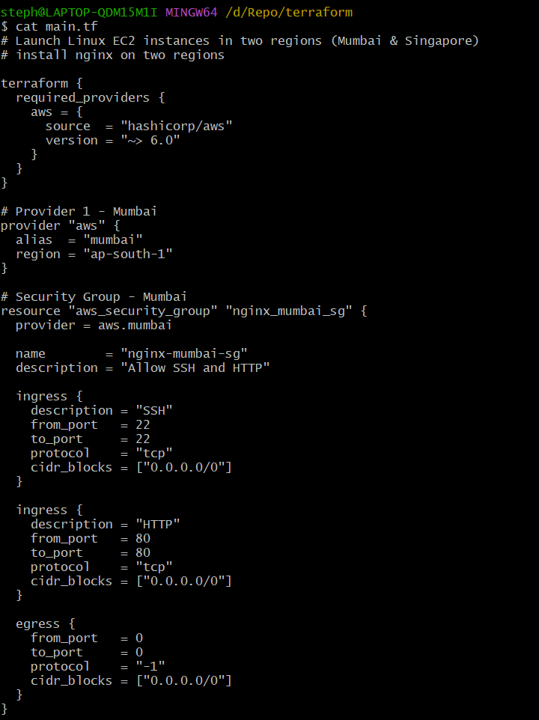
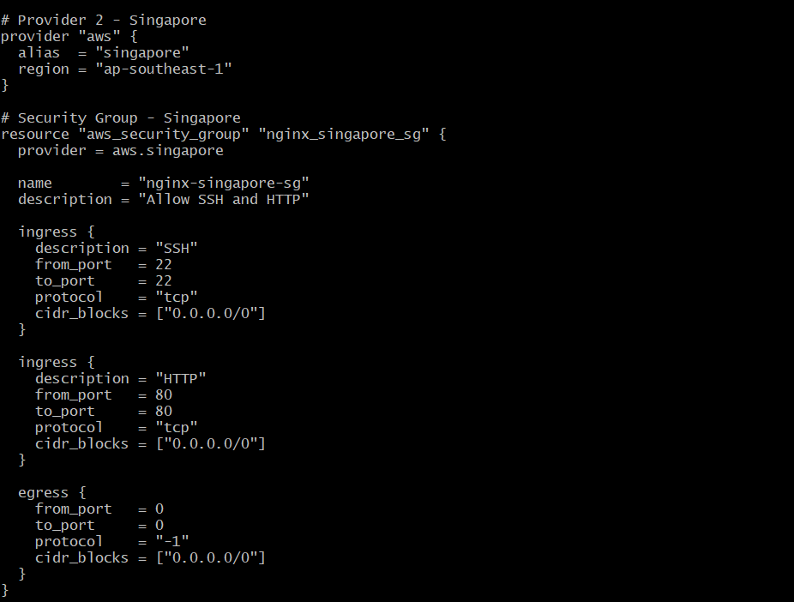
- Create EC2 machines and install nginx for both regions:
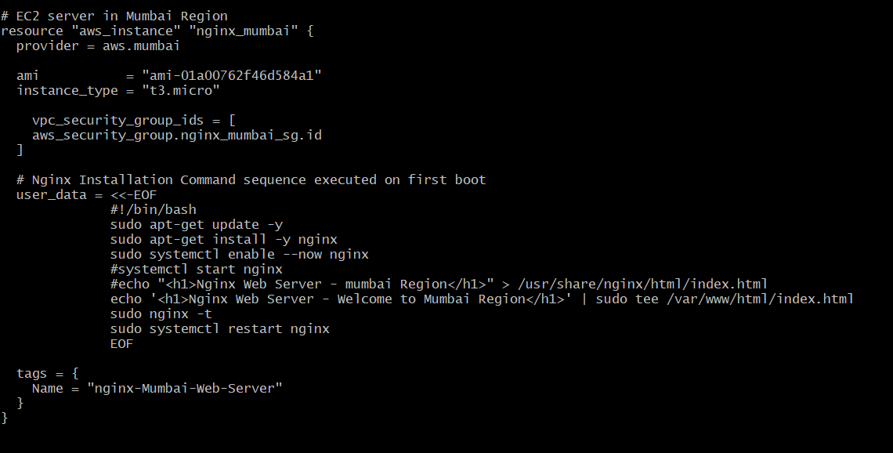
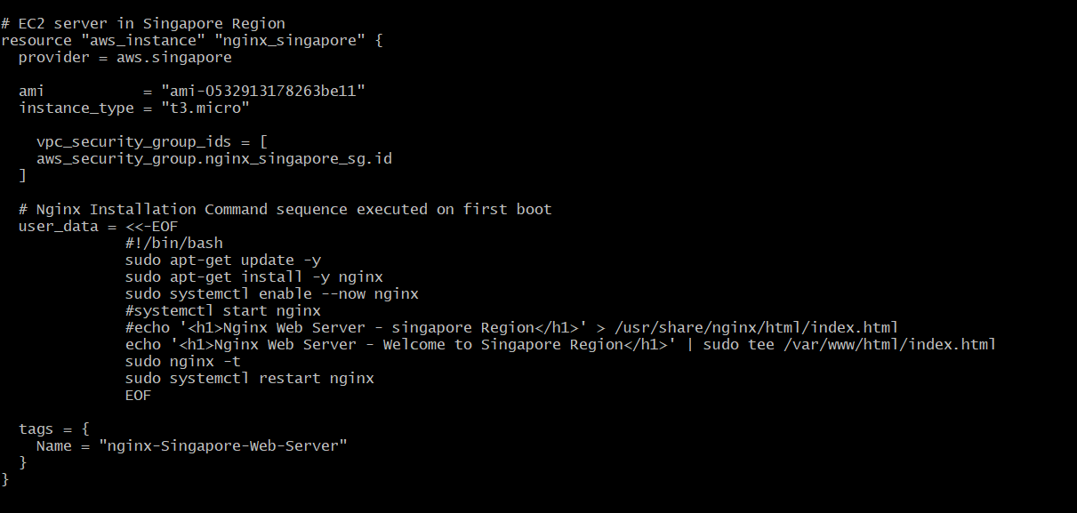
Running “terraform apply” command to creating the resources and install nginx for both EC2 machines through script:
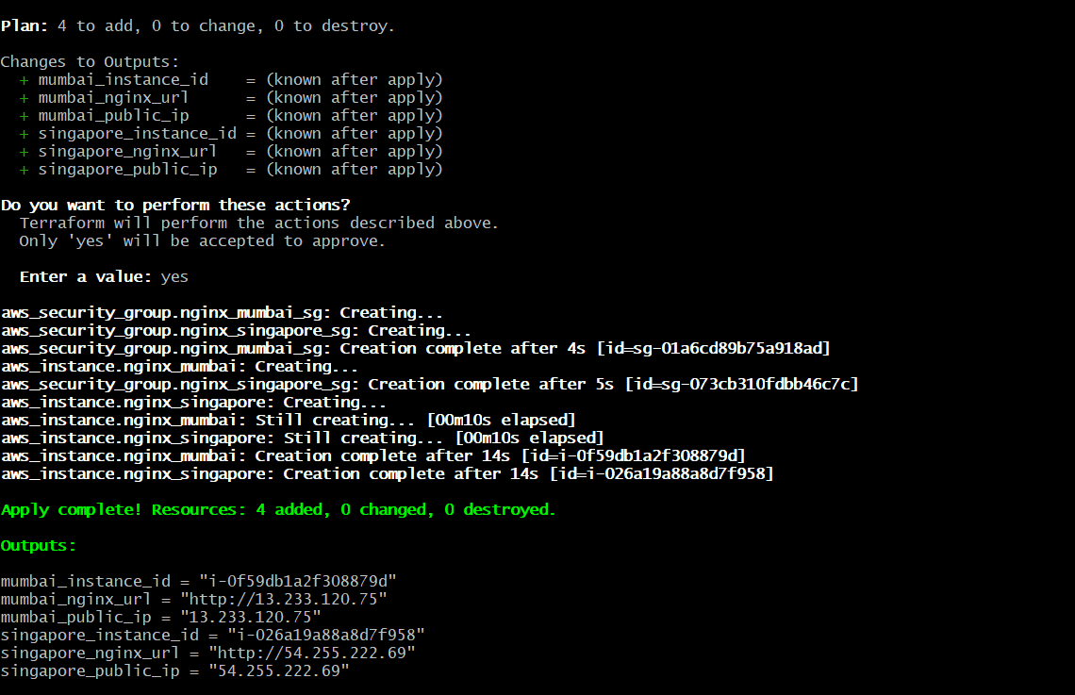
Output values:
Output.tf: Using below script to generated the output values
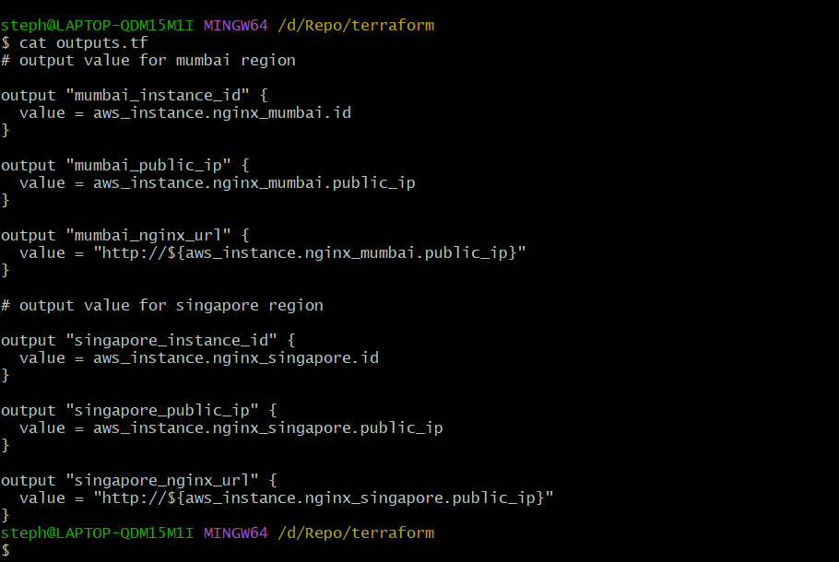
Output:
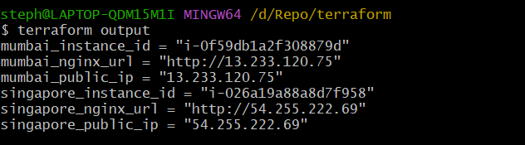
EC2 machine created for Mumbai region:
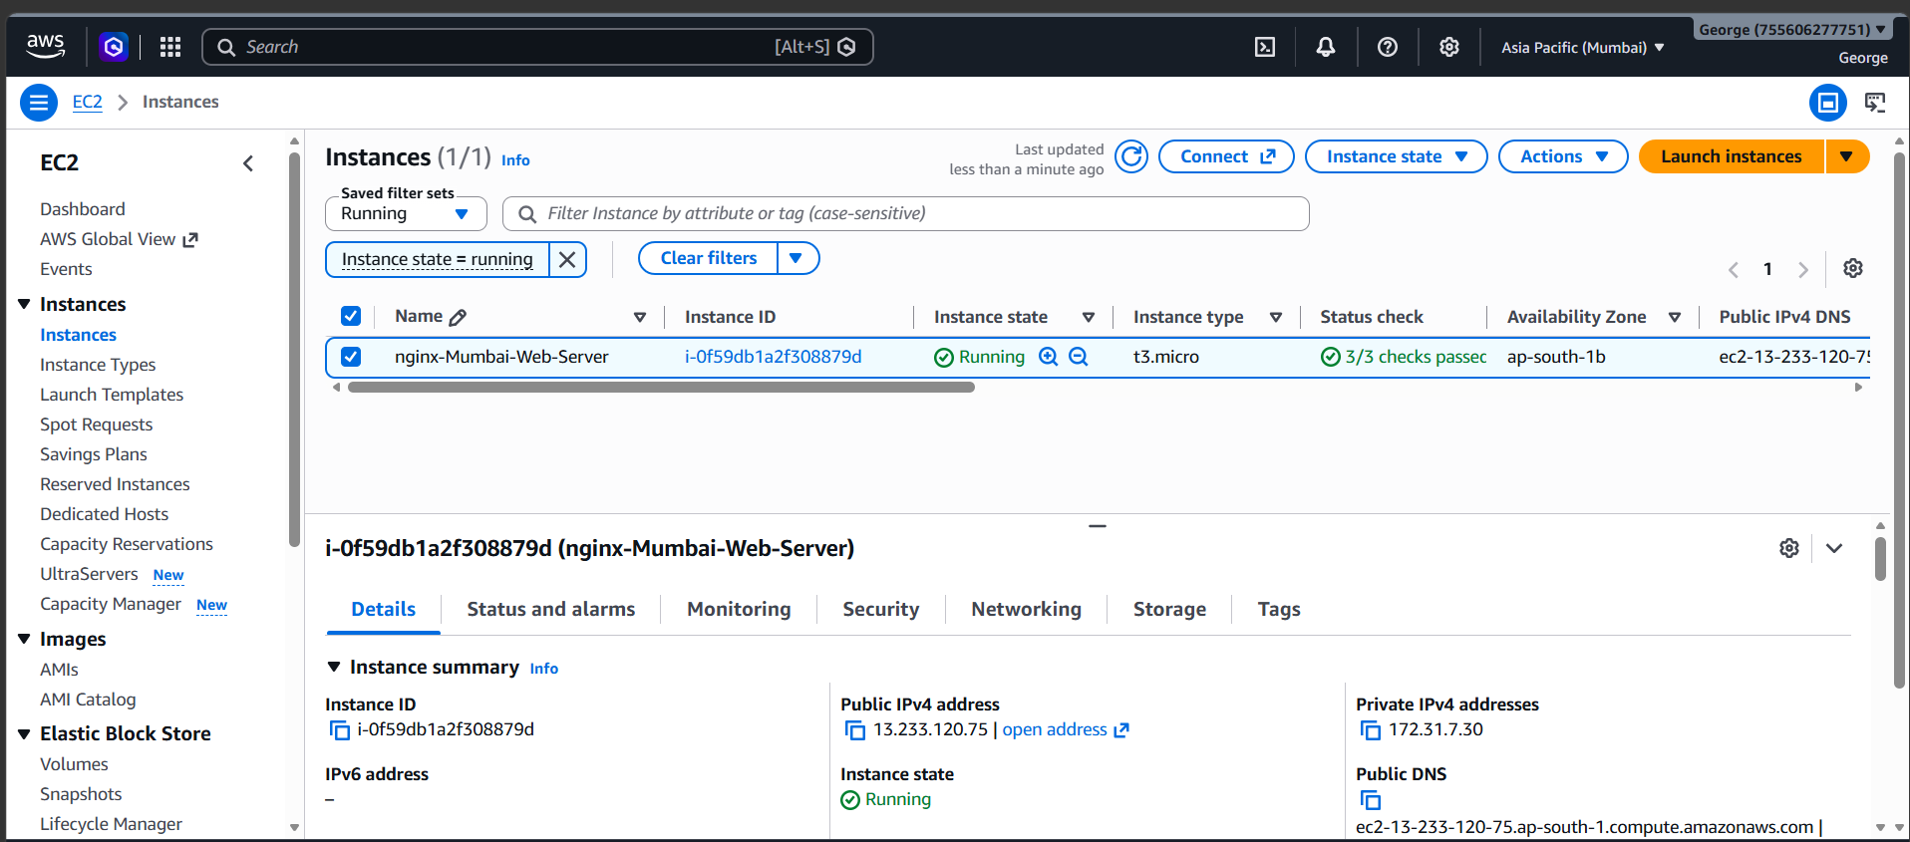
Nginx web server is running as successfully on Mumbai region:
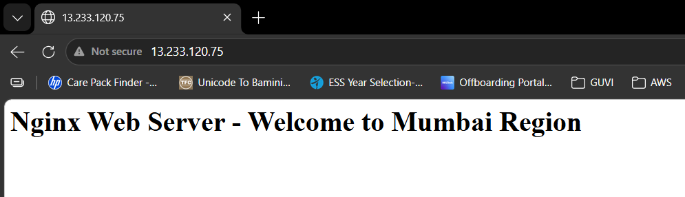

EC2 machine created for Singapore region:
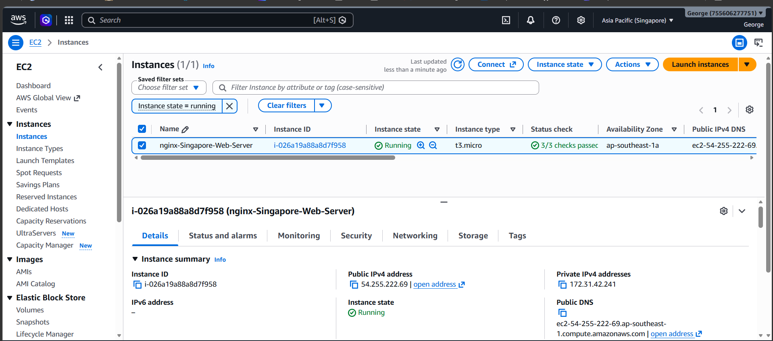

Nginx web server is running as successfully on Singapore region:
